3G611R (3G611R+)-How to limit download and upload rate of the computer？
Product line: 3G Question category: Function configurations

Q：Why we need to limit the computer’s download and upload speed？
A：In the LAN, multi computers share the same network, if someone download or view the video streams, he will influence others. As to this, you can limit the computer’s download rate through setting Traffic Control.

The topology should be as below：
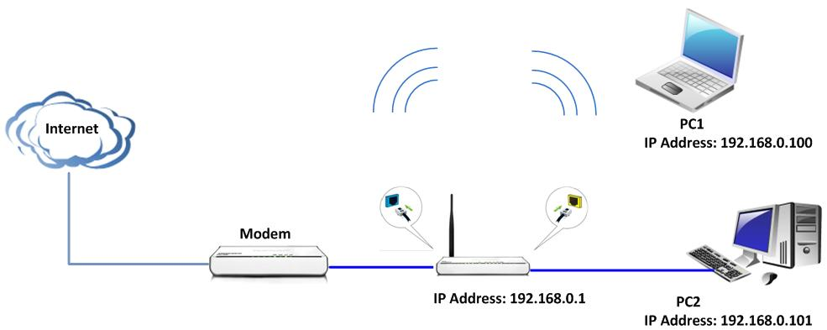

The Steps are as below:
1．Login to the router’s home page
2．Click Traffic Control and tick the Traffic Control to enable it.
For example, if we want to limit the maximum upload rate of the computer with IP address 192.168.0.100 to be 30Kbytes, please do following the picture as below.
Note: you need to set the correctly Upload BW and Download BW for the WAN. If you don’t know these information, please consult with your ISP. Otherwise, please pay attention to the Units.
1Mbps=128KBytes, 2Mbps=256KBytes
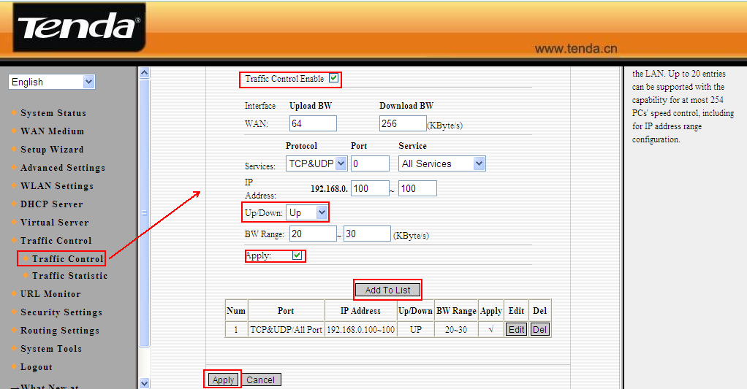
For example, we want limit the maximum download rate of the computer with IP address 192.168.0.100 to be 100KBytes. Please do following the picture as below.
Note: you need set the correctly Upload BW and Download BW for the WAN. If you don’t know these information, please consult with your ISP. Otherwise, please pay attention to the Units.
1Mbps=128KBytes, 2Mbps=256KBytes
